**Introduction :**

The DevOps is the combination of two words, one is **Development** and other is **Operations**. It is a culture to promote the development and operation process collectively.

The DevOps tutorial will help you to learn DevOps basics and provide depth knowledge of various DevOps tools such as **Git, Ansible, Docker, Puppet, Jenkins, Chef, Nagios**, and **Kubernetes**.

**What is DevOps?**

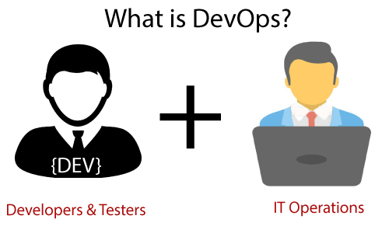

**Why DevOps :**

Before going further, we need to understand why we need the DevOps over the other methods.

* The operation and development team worked in complete isolation.
* After the design-build, the testing and deployment are performed respectively. That's why they consumed more time than actual build cycles.
* Without the use of DevOps, the team members are spending a large amount of time on designing, testing, and deploying instead of building the project.
* Manual code deployment leads to human errors in production.
* Coding and operation teams have their separate timelines and are not in synch, causing further delays.

**DevOps History :**

* In 2009, the first conference named **DevOpsdays** was held in Ghent Belgium. Belgian consultant and Patrick Debois founded the conference.
* In 2012, the state of DevOps report was launched and conceived by Alanna Brown at Puppet.
* In 2014, the annual State of DevOps report was published by Nicole Forsgren, Jez Humble, Gene Kim, and others. They found DevOps adoption was accelerating in 2014 also.
* In 2015, Nicole Forsgren, Gene Kim, and Jez Humble founded DORA (DevOps Research and Assignment).
* In 2017, Nicole Forsgren, Gene Kim, and Jez Humble published "Accelerate: Building and Scaling High Performing Technology Organizations".